

**Department of Information and Communication Engineering**

**Pabna University of Science and Technology**

**Faculty of Engineering and Technology**

**B.Sc. (Engineering) 4th Year 1st Semester Exam-2023**

Session: 2019-2020

**Course Title:** Information Theory and Coding Sessional.

**Course Code:** ICE-4106

**Practical Lab Report**

**Submitted By:** Md. Rashed

Roll No**:** 200613

Dept. of Information and Communication Engineering

Pabna University of Science and Technology

Pabna-6600, Bangladesh

**Submitted To:** Sohag Sarker

Associate Professor

Dept. of Information and Communication Engineering

Pabna University of Science and Technology

Pabna-6600, Bangladesh

Date of Submission: Signature

|  |  |  |
| --- | --- | --- |
| **SL. NO** | **Experiment Name** | **Page** |
| 01 | Write a program to implement Huffman code using symbols with their corresponding probabilities. | 3-5 |
| 02 | Write a program to simulate convolutional coding based on their encoder structure. | 6-9 |
| 03 | Write a program to implement Lempel-Ziv code. | 7-11 |
| 04 | Write a program to implement Hamming code. | 12-14 |
| 05 | A binary symmetric channel has the following noise matrix with probability, $P\left(X/Y\right)=$ $\left[\begin{matrix}\frac{2}{3} & \frac{1}{3} \\ \frac{1}{3} & \frac{2}{3}\end{matrix}\right]$  Now find the Channel Capacity C. | 15-17 |
| 06 | Write a program to check the optimality of Huffman code. | 18-19 |
| 07 | Write a code to find the entropy rate of a random walk on the following weighted graph | 20-23 |
| 08 | Write a program to find conditional entropy and join entropy and mutual information based on the following matrix.   |  |  |  |  |  | | --- | --- | --- | --- | --- | | X  Y | 1 | 2 | 3 | 4 | | 1 |  |  |  |  | | 2 |  |  |  |  | | 3 |  |  |  |  | | 4 | $$\frac{1}{4}$$ | 0 | 0 | 0 | | 24-25 |

**INDEX**

**Experiment No:** 01

**Experiment Name:** Write a program to implement Huffman code using symbols with their corresponding probabilities.

**Theory: Huffman Coding:** Huffman coding is a widely used data compression technique that assigns variable-length binary codes to symbols based on their frequencies, ensuring that more common symbols get shorter codes while less common ones receive longer codes. This method is optimal for creating prefix-free codes, meaning no code is a prefix of another, which guarantees unambiguous decoding. Huffman codes minimize the average length of encoded data, achieving compact and efficient representation that approaches the theoretical limit set by Shannon's entropy for a given set of source symbols and probabilities. By constructing a binary tree where each symbol's path dictates its code, Huffman coding ensures the most efficient compression possible for the given source statistics.

**Binary Huffman coding Algorithm: -**

For the design of binary Huffman codes, the Huffman coding algorithm is as follows:

1. The source symbol are listed in order of decreasing probability. The two source symbols of lowest probability are assigned a O and a 1. This part of the step is referred to as a splitting stage.

2. These two source symbols are regarded as being combined into a new source symbol with probability equal to the sum of the two original probabilities. The probability of the new Symbol is placed in the list in accordance with its value.

3. The procedure is repeated until we are left with a final list of source statistics of only two for which the code for each a O and 1 are assigned. The code for each source symbol is found by working backward and tracing the Sequence of 0’s and 1’s assigned to that Symbol as well as its successors.

**Example**: Consider a 5-symbol source with the following probability assignments:

P(S1) =0.2, P(S2) =0.4, P (S3) =0.1, P(S4) =0.1, P(S5) =0.2

By re-ordering the symbols in decreasing order of probability, we get: {S2, S1, S5, S3, S4}

The re- ordered source is then reduced to the Source S3 with only two symbols as shown in Figure 1, Where the arrow-head point to the combined symbol created in Sy by the com- bination of the last two symbols from Sj-1 Starting with the trivial compact code of {0,1} for S3 and working back to S a compact code is designed for each reduced source Sj; and shown in figures. In each Sj the code word for the last two symbols is produced by taking the code word of the symbol pointed to by the arrowhead and appending a 0 and 1 form two new code words. The Huffman code itself is the bit sequence generated by the path from the root to the corresponding leaf node.

|  |  |  |  |  |  |
| --- | --- | --- | --- | --- | --- |
| Symbol | Stage-01 | Stage-02 | Stage-03 | Stage-04 | Stage-5 |
| S1 | 0.4 | 0.4 | 0.4 | 0.6 | 1 |
| S2 | 0.2 | 0.2 | 0.4 | 0.4 |  |
| S3 | 0.2 | 0.2 | 0.2 |  |  |
| S4 | 0.1 | 0.2 |  |  |  |
| S5 | 0.1 |  |  |  |  |

Figure-01: Binary Huffman Coding Table

The binary Huffman Code is:

| Symbol | Probability (Si​) | Huffman Code |
| --- | --- | --- |
| S1 | 0.2 | 10 |
| S2 | 0.4 | 00 |
| S3 | 0.1 | 010 |
| S4 | 0.1 | 011 |
| S5 | 0.2 | 11 |

Figure-02: Huffman Code Table

In source code, we replace the symbol as

S1 = A, S2 = B, S3 = C, S4 = D, S5 = E

**Python Source Code:**

|  |
| --- |
| import heapq  # Class for creating nodes of the Huffman tree  class HuffmanNode:  def __init__(self, char, freq):  self.char = char  self.freq = freq  self.left = None  self.right = None  # Define comparison between nodes for the priority queue  def __lt__(self, other):  # Ensure internal nodes are compared by frequency only  if self.char is None and other.char is None:  return self.freq < other.freq  if self.char is None:  return False  if other.char is None:  return True  return self.freq < other.freq if self.freq != other.freq else self.char < other.char  # Custom function to build a Huffman tree that matches a specific code structure  def build_custom_huffman_tree():  # Manually create nodes with required structure  nodeA = HuffmanNode('A', 0.2)  nodeB = HuffmanNode('B', 0.4)  nodeC = HuffmanNode('C', 0.1)  nodeD = HuffmanNode('D', 0.1)  nodeE = HuffmanNode('E', 0.2)  # Manually create the tree structure to ensure the desired codes  # Create internal nodes to merge them according to the custom structure  internal1 = HuffmanNode(None, nodeC.freq + nodeD.freq)  internal1.left = nodeC # C: 1100  internal1.right = nodeD # D: 1101  internal2 = HuffmanNode(None, nodeA.freq + internal1.freq)  internal2.left = internal1 # Codes for C and D  internal2.right = nodeA # A: 111  internal3 = HuffmanNode(None, nodeE.freq + internal2.freq)  internal3.left = nodeE # E: 10  internal3.right = internal2 # Codes for A, C, D  root = HuffmanNode(None, nodeB.freq + internal3.freq)  root.left = nodeB # B: 0  root.right = internal3 # Codes for A, C, D, E  return root  # Function to build the Huffman codes from the Huffman tree  def build_codes(root):  codes = {}  # Helper function to traverse the tree and assign codes  def generate_code(node, current_code):  if node is None:  return  if node.char is not None:  codes[node.char] = current_code  generate_code(node.left, current_code + "0")  generate_code(node.right, current_code + "1")  generate_code(root, "")  return codes  # Build the custom Huffman tree and codes  root = build_custom_huffman_tree()  codes = build_codes(root)  # Display the Huffman codes  print("Huffman Codes:")  for symbol in ['A', 'B', 'C', 'D', 'E']:  print(f"{symbol}: {codes[symbol]}") |

**Output:**

Huffman Codes:

A: 111

B: 0

C: 1100

D: 1101

E: 10

**Experiment No:** 02

**Experiment Name:** Write a program to simulate convolutional coding based on their encoder structure.

**Theory:**

**Convolution Coding:**  
Convolution codes, or Trellis Code, introduce memory into the coding process to improve the error-correcting capabilities of the codes. The coding and decoding processes that are applied to error-correcting block codes are memoryless. The encoding and decoding of the block depend only on that block and is independent of any other block. They do this by making the parity-checking bits dependent on the bit values in several consecutive blocks.

Say, we have a message source that generates a sequence of information digits $U_{i}$ ​. We will assume that the information digits are binary, i.e., information bits. These information bits are fed into a convolution encoder. As an example, consider the encoder shown below. This encoder is a finite-state machine that has (a finite) memory.

Its current output depends on the current input and on a certain number of past inputs. In the example, its memory is 2 bits, i.e., it contains a shift-register that keeps stored the values of the last two information bits. Moreover, the encoder has several modulo-2 adders. The output of the encoder is the codeword bits that will be transmitted over the channel. In our example, for every information bit, two codeword bits are generated. Hence the encoder rate is $R_{t}$ =1/2 bits.

In general, the encoder can take $n_{i}$ ​ information bits to generate $n_{c}$ codeword bits, yielding an encoder rate of $R_{t}$ = $n_{i}$/ $n_{c}$ bits.

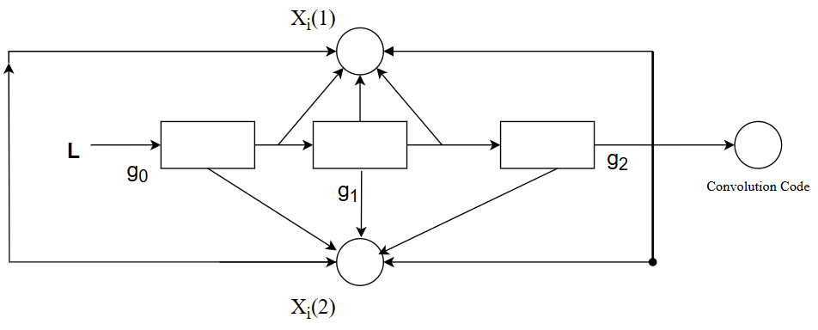

To make sure that the outcome of the encoder is a deterministic function of the sequence of input bits, we ask the memory cells of the encoder to contain zeros at the beginning of the encoding process. Moreover, once $L_{1}$ information bits have been encoded, we stop the information bit sequence and will feed T dummy zero-bits as inputs instead, where T is chosen to be equal to the memory size of the encoder. These dummy bits will make sure that the state of the memory cells is turned back to zero. Here in the above diagram,

L = the message length,

m = number of shift registers,

n = number of modulo-2 adders.

Output = n(m +L) bits, and code rate, $r=\frac{L}{n\left(m+L\right)} ;$

$r=\frac{L}{nL} L≫m$

$r=\frac{1}{n}$

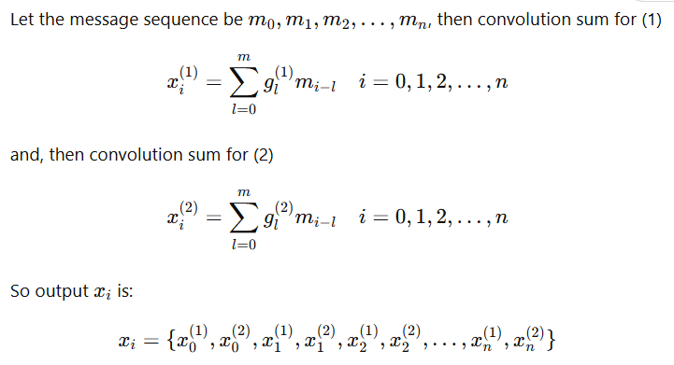**Constraint length, $k=m+1$**  . If $g_{0}^{(1)}$ (1)​, $g_{1}^{(1)}$, $g_{2}^{(1)}$------ $g_{m}^{(1)}$ are the states of shift register, then the input-top adder output path is given by,

$g_{0}^{(1)}$ (1)​, $g_{1}^{(1)}$, $g_{2}^{(1)}$------ $g_{m}^{(1)}$ are the state of the shift register, then the input-bottom adder output path is given by $g_{0}^{(2)}$ (1)​, $g_{1}^{(2)}$, $g_{2}^{(2)}$------ $g_{m}^{(2)}$

**Math:**

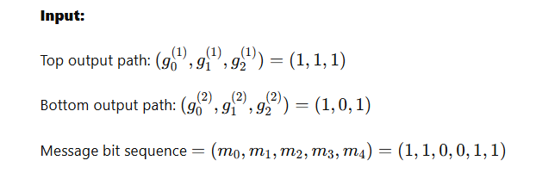

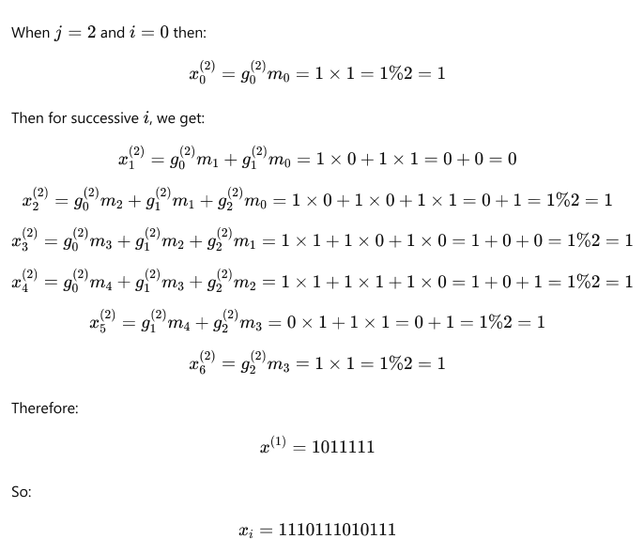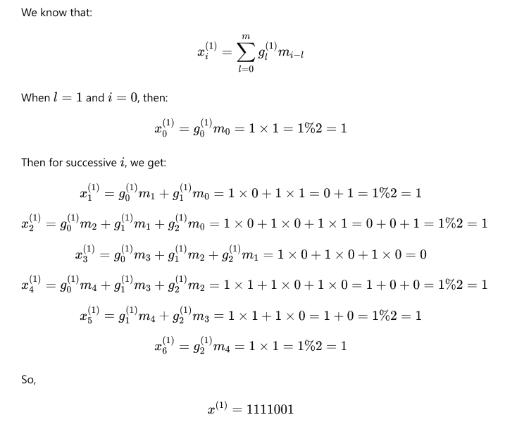

**Python Source Code:**

|  |
| --- |
| import numpy as np  # Generator polynomials for the top and bottom paths  g0 = [1, 1, 1] # Top path polynomial  g1 = [1, 0, 1] # Bottom path polynomial  # Input message bit sequence  message = [1, 0, 0, 1, 1]  # Initialize the shift register with zeros (length of max polynomial)  shift_register = [0, 0, 0]  # Function to compute the convolutional output  def convolutional_encode_bit(shift_register, g):  # Compute the output bit based on the generator polynomial  output_bit = np.bitwise_xor.reduce([shift_register[i] * g[i] for i in range(len(g))])  return output_bit  # Encode the message  encoded_message = []  for bit in message:  # Update the shift register (only once per input bit)  shift_register.insert(0, bit)  shift_register.pop() # Keep length constant    # Compute the top path output bit (g0) and bottom path output bit (g1)  top_bit = convolutional_encode_bit(shift_register, g0)  bottom_bit = convolutional_encode_bit(shift_register, g1)    # Append the output to the encoded message  encoded_message.extend([top_bit, bottom_bit])  print("Input message bit sequence:", message)  print("Encoded convolutional code:", encoded_message) |

**Output:**

Input message bit sequence: [1, 0, 0, 1, 1]

Encoded convolutional code: [1, 1, 1, 0, 1, 1, 1, 1, 0, 1]

**Experiment No:** 03

**Experiment Name:** Write a program to implement Lempel-Ziv code.

**Theory:**

Lempel-Ziv is a universal lossless data compression algorithm created by Abraham Lempel, Jacob Ziv. It was the algorithm of the widely used Unix file compression utility compress and is used in the GIF image format.

Lempel-Ziv algorithm is accomplished by parsing the source data stream into segments that are the shortest subsequence not encountered previously. To illustrate, let us consider an input binary sequence as follows: 000101111001010010001 ...

Let us assume 0 and 1 are already stored so, subsequence store: 0, 1

Data to be parsed: 000101110001...

The encoding process begins at left. As 0 and 1 are already stored, the shortest subsequence of data stream one written as

**subsequence stored**: 0, 1, 00

**Data to be parsed**: 01011110010100101...

The second and the next sequences are:

**Subsequence stored**: 0, 1, 00, 01

**Data to be parsed**: 01110010100101...

We continue this until the given data stream is completely parsed. Now the binary code blocks of the sequences are:

* **Numerical positions**: 1 2 3 4 5 6 7 8 9
* **Subsequence**: 0 1 00 01 011 10 010 100 101
* **Numerical representation**: 11 12 42 21 41 61 62
* **Binary encoded blocks**: 0010 0011 1001 0100 1000 1100 1101

**Figure**: Illustrating the encoding process performed by the Lempel-Ziv algorithm.

From the figure, the first row shows the numerical position of individual subsequence in the code. A sequence of data stream 010 consists of the concatenation of the subsequence 01 in position 4 and symbol 0 in position 1; hence the numerical representation is 41. Similarly, others are.

The decoder is just simple as the encoder. Use the pointer to identify the root subsequence and appends the innovation symbol. Such as, the binary block encoded block 1101 in position 9. The last bit is the innovation symbol.

In contrast to Huffman coding, the Lempel-Ziv algorithm uses fixed length codes to represent a variable number of source system.

**Python Source Code:**

|  |
| --- |
| def lempel_ziv_encode(binary_sequence):  # Initialize dictionary with empty sequence  dictionary = {}  current_subseq = ""  output = []  code = 1 # Start encoding from 1  subsequences = [] # List to store subsequences  for bit in binary_sequence:  current_subseq += bit  if current_subseq not in dictionary:  # Add the new subsequence to the dictionary with the next code  binary_code = format(code, '04b') # 4-bit encoding as shown in example  dictionary[current_subseq] = binary_code  output.append(binary_code)  subsequences.append(current_subseq)  code += 1  current_subseq = "" # Reset current subsequence for the next sequence  return output, dictionary, subsequences  # Example binary sequence  binary_sequence = "000101100101001011"  encoded_output, encoding_dictionary, subsequences = lempel_ziv_encode(binary_sequence)  # Print formatted output  print("X = columns 1 through", len(binary_sequence))  print(" ".join(binary_sequence)) # Display original sequence  print("\nSubsequences = ", subsequences)  print("\nBinary Encoded Blocks = ", " ".join(encoded_output)) |

**Output:**

X = columns 1 through 18

0 0 0 1 0 1 1 0 0 1 0 1 0 0 1 0 1 1

Subsequences = ['0', '00', '1', '01', '10', '010', '100', '101']

Binary Encoded Blocks = 0001 0010 0011 0100 0101 0110 0111 1000

**Experiment No:** 04

**Experiment Name:** Write a program to implement Hamming code.

**Theory:** Hamming Codes, created by Richard Hamming in the 1950s, are a type of linear error-correcting code. They are designed to correct single-bit errors and can also detect errors involving up to two bits during data transmission.

In mathematical terms. Hamming codes are a class of binary linear codes.

For each integer r≥2, Hamming codes have a block n = 2r-1 and message length k =2r-1-1. Hence the rate of Hamming codes is R= k/n = 1-r/(2r-1), which is highest possible for codes with minimum distance 3 and block length 2r-1. The parity check matrix of a Hamming code is constructed by listing all columns of length r that are non-zero, which means that the dual code of the Hamming code is the punctured.

**Parity Check Matrix**: The parity check matrix H is constructed by listing all columns of length n that are non-zero and pairwise independent. The relationship HG=0 must hold, where G is the generator matrix.

**Construction of G and H**:

* The generator matrix $G≔\left(\left.I_{k}\right|A^{T}\right)$ is used for encoding data, where Ik is the identity matrix of size k and $A^{T}$ is the transpose of the matrix representing the redundant bits.
* The parity check matrix $H≔\left(\left.A\right|I_{n-k}\right)$ is used for error detection.

The code generator matrix G and the parity check matrix H are:

G= $\left(\begin{matrix}1 & 0 & 0 & 0 & 1 & 1 & 0 \\ 0 & 1 & 0 & 0 & 1 & 0 & 1 \\ 0 & 0 & 1 & 0 & 0 & 1 & 1 \\ 0 & 0 & 0 & 1 & 1 & 1 & 1\end{matrix}\right)$

And

H = $\left(\begin{matrix}1 & 1 & 0 & 1 & 1 & 0 & 0 \\ 1 & 0 & 1 & 1 & 0 & 1 & 0 \\ 0 & 1 & 1 & 1 & 0 & 0 & 1\end{matrix}\right)$

Finally, these metrics can be mutated into equivalent non-systematic codes by the following operations:

* Column permutation (swapping columns)
* Elementary row operation (replacing a row with a linear combination of rows)
* Hamming code can be extended to an [8,4] code by including an additional parity bit alongside the [7,4] encoded word. This added parity bit enhances the error-detection capability. The revised matrix represents this extension, although the diagram provided is not intended to match the specific matrix used in this example.

G= $\left(\begin{matrix}1 & 1 & 1 & 0 & 0 & 0 & 0 & 1 \\ 1 & 0 & 0 & 1 & 1 & 0 & 0 & 1 \\ 0 & 1 & 0 & 1 & 0 & 1 & 0 & 1 \\ 1 & 1 & 0 & 1 & 0 & 0 & 1 & 0\end{matrix}\right)$

And

H = $\left(\begin{matrix}1 & 0 & 1 & 0 & 1 & 0 & 1 & 0 \\ 0 & 1 & 1 & 0 & 0 & 1 & 1 & 0 \\ 0 & 0 & 0 & 1 & 1 & 1 & 1 & 0 \\ 1 & 1 & 1 & 1 & 1 & 1 & 1 & 1\end{matrix}\right)$

G elementary now operations can be used to obtain an equivalent matrix to H in systematic form.

$$H=\left(\left.\begin{matrix}0 & 0 & 1 & 1 \\ 1 & 0 & 1 & 1 \\ 1 & 1 & 0 & 1 \\ 1 & 1 & 1 & 0\end{matrix}\right|\begin{matrix}1 & 0 & 0 & 0 \\ 0 & 1 & 0 & 0 \\ 0 & 0 & 1 & 0 \\ 0 & 0 & 0 & 1\end{matrix}\right)$$

The matrix A is apparent, and the systematic form of G is written

$$H=\left(\left.\begin{matrix}1 & 0 & 0 & 0 \\ 0 & 1 & 0 & 0 \\ 0 & 0 & 1 & 0 \\ 0 & 0 & 0 & 1\end{matrix}\right|\begin{matrix}0 & 1 & 1 & 1 \\ 1 & 0 & 1 & 1 \\ 1 & 1 & 0 & 1 \\ 1 & 1 & 1 & 0\end{matrix}\right)$$

By adding the fourth row, the sum of all the code word bits (both data and parity) is calculated to create the fourth parity bit. This extra parity bit helps ensure that the overall code word maintains even parity, further enhancing error detection and correction capabilities.

**Source Code (Python):**

|  |
| --- |
| import numpy as np  # Step 1: User input for 4-bit binary message  data_bits = input("Enter 4 bit message (e.g., 1010): ")  # Convert input string to array of integers  M = np.array([int(bit) for bit in data_bits])  # Step 2: Define individual data bits  d1 = np.array([1, 0, 0, 0])  d2 = np.array([0, 1, 0, 0])  d3 = np.array([0, 0, 1, 0])  d4 = np.array([0, 0, 0, 1])  # Step 3: Calculate Parity Bits  P1 = (d2 + d3 + d4) % 2  P2 = (d1 + d3 + d4) % 2  P3 = (d1 + d2 + d4) % 2  # Step 4: Construct Generator Matrix G  G = np.array([P1, P2, P3, d1, d2, d3, d4]).T # Transpose to match MATLAB's layout  # Step 5: Construct Parity-check Matrix H with correct dimensions  H = np.array([  [1, 0, 0, 1, 1, 0, 1],  [0, 1, 0, 1, 0, 1, 1],  [0, 0, 1, 0, 1, 1, 1]  ])  # Step 6: Generate the Code Word  code_word = np.dot(M, G) % 2  # Display results  print("Generator matrix G =\n", G)  print("Code word =", code_word)  # Step 7: Calculate Syndrome E  E = np.dot(H, code_word) % 2  print("Syndrome E =", E)  # Step 8: Input an erroneous received code word  error_code_input = input("Give an erroneous received Hamming code word (e.g., 1011010): ")  ERC = np.array([int(bit) for bit in error_code_input])  # Step 9: Calculate syndrome for error detection  E_err = np.dot(H, ERC) % 2  print("Error syndrome for received code:", E_err)  # Step 10: Identify error position and correct if necessary  error_position = 0  for i in range(7):  if np.array_equal(E_err, H[:, i]):  error_position = i + 1 # Convert to 1-based index  break  print("Error position:", error_position)  # Step 11: Correct the error if detected  if error_position != 0:  ERC[error_position - 1] = 1 - ERC[error_position - 1] # Flip the bit at error position  print("Hamming code word after error correction:", ERC)  else:  print("No error detected.") |

**Output:**

Enter 4-bit message: 1010

Generator matrix G =

[[0 1 1 1 0 0 0]

[1 0 1 0 1 0 0]

[1 1 0 0 0 1 0]

[1 1 1 0 0 0 1]]

Code word = [1 0 1 1 0 1 0]

Syndrome E = [0 0 0]

Give an erroneous received Hamming code word: 1011011

Error syndrome for received code: [1 1 1]

Error position: 7

Hamming code word after error correction: [1 0 1 1 0 1 0]

**Experiment No:** 05

**Experiment Name:** A binary symmetric channel has the following noise matrix with probability,

P(Y/X) = $\left[\begin{matrix}\frac{2}{3} & \frac{1}{3} \\ \frac{1}{3} & \frac{2}{3}\end{matrix}\right]$. Now Find the Channel Capacity C.

**Theory:** A binary symmetric channel (BSC) is a widely used model in coding and information theory to represent a communication channel. In this model, a transmitter sends a bit (either zero or one), and the receiver receives a bit. Typically, the bit is transmitted correctly, but there is a small chance, known as the "crossover probability," that the bit will be flipped. The BSC is popular in information theory due to its simplicity and ease of analysis.

A binary symmetric channel (BSC) with crossover probability p is defined as a channel with binary input and output, where the probability of an error (bit flip) is p. This means that if X represents the transmitted random variable and Y the received random variable, the channel's behaviours can be described by conditional probabilities. Specifically, the channel characteristics are:

Pr (Y = 0 | *X* = 0) = 1 − *p*  
Pr (*Y* = 0 | *X* = 1) = *p*  
Pr (*Y* = 1 | *X* = 0) = *p*  
Pr (*Y* = 1 | *X* = 1) = 1 − *p*

1. It is assumed that 0 ≤ *p* ≤ 1/2. If *p* > 1/2, then the receiver can swap the output (interpret 1 when it sees 0, and vice versa) and obtain an equivalent channel with crossover probability 1 − *p* ≤ 1/2.
2. The binary symmetric channel (BSC) is popular among theorists because it is one of the simplest noisy channels to analyze. Many complex communication theory problems can be simplified and studied using the BSC model.
3. Conversely, finding effective transmission methods for the BSC can lead to solutions that apply to more complex communication channels, providing a foundation for developing strategies to handle a wider range of channel conditions.

1-p

1-p

p

p

0

0

1

1

Transmitted signals

Received Signal

Figure 1: Binary symmetric channel

A binary symmetric channel (BSC) is a model where input symbols are flipped with a probability p. It is the simplest representation of a channel with errors but effectively captures much of the complexity of error-prone communication. When an error occurs, a '0' is received as a '1' and vice versa. However, the received bits do not indicate where the errors happened, making all bits appear unreliable. The information capacity of a binary symmetric channel with parameter p is defined accordingly.

C = 1- H(p) bits. ------------------------(i)

Here condition probability H(p) or H(Y/X) calculate using following formula,

H(p) = (1-p) log $\frac{1}{1-p}$ + p log $\frac{1}{p}$------------------(ii)

**Source Code (Python):**

|  |
| --- |
| import numpy as np  def enter_symmetric_matrix(size):  """  Prompt the user to enter elements of a symmetric matrix.  Parameters:  - size (int): The size of the matrix.  Returns:  - np.ndarray: The symmetric matrix.  """  matrix = np.zeros((size, size))  for i in range(size):  for j in range(size):  if j >= i: # To ensure the matrix is symmetric  element = input(f"Enter symmetric matrix element ({i+1},{j+1}) [as a fraction, e.g., 2/3]: ")  matrix[i][j] = eval(element) # Convert string to fraction  matrix[j][i] = matrix[i][j] # Make the matrix symmetric  return matrix  def conditional_probability(matrix):  """  Calculate conditional probabilities from the symmetric matrix.  Parameters:  - matrix (np.ndarray): The symmetric matrix.  Returns:  - np.ndarray: The conditional probabilities.  """  row_sums = np.sum(matrix, axis=1, keepdims=True)  return matrix / row_sums  def channel_capacity(matrix):  """  Calculate the channel capacity of a binary symmetric channel.  Parameters:  - matrix (np.ndarray): The symmetric matrix.  Returns:  - float: The channel capacity.  """  p_0 = matrix[0, 0] # Probability of receiving 0 given sent 0  p_1 = matrix[1, 1] # Probability of receiving 1 given sent 1  return 1 - (p_0 * np.log2(p_0) + p_1 * np.log2(p_1))  def format_scientific(value):  """Format a number in scientific notation."""  return "{:.2e}".format(value)  # Main program  if __name__ == "__main__":  size = 2 # For a binary symmetric channel  print("Please enter the elements of a symmetric matrix (2x2):")    symmetric_matrix = enter_symmetric_matrix(size)    print("\nMatrix:")  print(symmetric_matrix)    prob_matrix = conditional_probability(symmetric_matrix)  print("\nConditional Probability:")  for i in range(size):  for j in range(size):  prob = prob_matrix[i][j]  print(f"H(Y|X) = {format_scientific(prob)} for P(Y={j+1}|X={i+1})")    capacity = channel_capacity(prob_matrix)  print("\nChannel Capacity:", format_scientific(capacity)) |

**Output:**

Please enter the elements of a symmetric matrix (2x2):

Enter symmetric matrix element (1,1) [as a fraction, e.g., 2/3]: 2/3

Enter symmetric matrix element (1,2) [as a fraction, e.g., 2/3]: 1/3

Enter symmetric matrix element (2,2) [as a fraction, e.g., 2/3]: 2/3

Matrix:

[[0.66666667 0.33333333]

[0.33333333 0.66666667]]

Conditional Probability:

H(Y|X) = 6.67e-01 for P(Y=1|X=1)

H(Y|X) = 3.33e-01 for P(Y=2|X=1)

H(Y|X) = 3.33e-01 for P(Y=1|X=2)

H(Y|X) = 6.67e-01 for P(Y=2|X=2)

Channel Capacity: 1.78e+00

**Experiment No:** 06

**Experiment Name:** Write a program to check the optimality of Huffman code.

**Theory:** To verify the optimality of a Huffman code, you can apply the Kraft inequality, which states that the sum of the inverse of all the code word lengths (in bits) must be less than or equal to 1. If a code satisfies this condition, it is considered optimal. Another method is to check if the code is prefix-free, meaning no code word is the beginning segment of any other code word, as prefix-free codes are always optimal. A third approach is to compare the average length of the Huffman code with the entropy of the source; if they are equal, the code is optimal. If the code is not optimal in any of these cases, you can use the standard algorithm for generating a new, optimal Huffman code. In this source code, the Kraft inequality is used to confirm the optimality of the Huffman code.

**Source Code (Python):**

|  |
| --- |
| import numpy as np  import heapq  # Define the symbols and their frequencies  symbols = ['a', 'b', 'c', 'd', 'e']  frequencies = [25, 25, 20, 15, 15]  # Check if lengths match  if len(symbols) != len(frequencies):  print("Error: Symbols and frequencies must have the same length")  exit()  # Calculate probabilities  probabilities = np.array(frequencies) / sum(frequencies)  def huffman_encode(symbols, probabilities):  """Encodes symbols using Huffman coding.  Args:  symbols: A list of symbols.  probabilities: A list of corresponding probabilities.  Returns:  A dictionary mapping symbols to their Huffman codes.  """  # Create a priority queue from the symbols and their probabilities  queue = [(p, s) for p, s in zip(probabilities, symbols)]  heapq.heapify(queue)  # Initialize the codes dictionary  codes = {}  # Build the Huffman tree  while len(queue) > 1:  p1, s1 = heapq.heappop(queue)  p2, s2 = heapq.heappop(queue)  for s in s1:  codes[s] = codes.get(s, '') + '0' # Add '0' to the code  for s in s2:  codes[s] = codes.get(s, '') + '1' # Add '1' to the code  heapq.heappush(queue, (p1 + p2, s1 + s2))  return codes  # Generate the Huffman codes  huffman_codes = huffman_encode(symbols, probabilities)  # Print output  print("Symbol:")  for symbol in symbols:  print(symbol)  print("\nCorresponding Frequencies of Symbols:")  for freq in frequencies:  print(freq)  print("\nCorresponding Probabilities of Symbols:")  for prob in probabilities:  print(f"{prob:.4f}")  # Sort Huffman codes by symbol  sorted_huffman_codes = sorted(huffman_codes.items())  print("\nHuffman Code:")  for symbol, code in sorted_huffman_codes:  print(f"{symbol}: {code}")  # Calculate inequality  inequality = sum(2**(-len(code)) for code in huffman_codes.values())  print(f"\nInequality: {inequality:.4f}")  # Calculate the average code length  average_code_length = sum(probabilities[i] * len(huffman_codes[symbols[i]]) for i in range(len(symbols)))  print(f"Average Code Length: {average_code_length:.4f}")  # Calculate entropy  entropy = -sum(probabilities[i] * np.log2(probabilities[i]) for i in range(len(symbols)))  print(f"Entropy: {entropy:.4f}")  # Check optimality  if inequality <= 1:  print("This is an optimal code.")  else:  print("This is not an optimal code.") |

**Output:**

Symbol:

a

b

c

d

e

Corresponding Frequencies of Symbols:

25

25

20

15

15

Corresponding Probabilities of Symbols:

0.2500

0.2500

0.2000

0.1500

0.1500

Huffman Code:

a: 10

b: 01

c: 00

d: 011

e: 111

Inequality: 1.0000

Average Code Length: 2.3000

Entropy: 2.2855

This is an optimal code.

**Experiment No:** 07

**Experiment Name:** Write a code to find the entropy rate of a random walk on the following weighted graph

**1**

**2**

**1**

**1**

**1**

**Theory:** The entropy of a stochastic process {Xi} is defined by

H(X) = $\lim_{n→∞}{\frac{1}{n}}$ H(X1,X2, . . . , Xn)

when the limit exists.

We now consider some simple examples of stochastic processes and their corresponding entropy rates.

1. Typewriter.

Consider the case of a typewriter that has m equally likely output letters. The typewriter can produce mn sequences of length n, all of them equally likely. Hence H(X1,X2, . . . , Xn) = log mn and the entropy rate is *H(X)* = log *m* bits per symbol.

2. X1,X2, . . . are id random variables. Then

H(X) = = = H(X1)

Sequence of independent but not identically distributed random variables.

In this case,

H (X1,X2, . . . , Xn) =

But the H(Xi)’s is all not equal. We can choose a sequence of distributions on (X1,X2……such that the limit of $\frac{1}{n}$ $\sum{H(Xi)}$ does not exist.

Consider a graph with m nodes labelled {1, 2, . . ., m}, with weight Wij ≥ 0 on the edge joining node i to node j. (The graph is assumed to be undirected, so that Wij = Wji. We set Wij = 0 if there is no edge joining nodes i and j.) A particle walks randomly from node to node in this graph. The random walk {Xn}, Xn ∈ {1, 2, . . ., m}, is a sequence of vertices of the graph. Given Xn = i, the next vertex j is chosen from among the nodes connected to node i with a probability proportional to the weight of the edge connecting i to j.

Thus, Pij = Wij/ $\sum_{k}{Wik}$.

In this case, the stationary distribution has a surprisingly simple form, which we will guess and verify. The stationary distribution for this Markov chain assigns probability to node i proportional to the total weight of the edges emanating from node i. Let,

$$Wi=\sum_{j}{Wij}$$

be the total weight of edges emanating from node i, and let,

$$Wi=\sum_{i,j;j>i}{Wij}$$

be the sum of the weights of the edges. Then ∑wi=2w. We now guess that the stationary distribution is

i =

We verify that this is the stationary distribution by checking that $μp= μ$.Here,

=

=

= j

Thus, the stationary probability of state i is proportional to the weight of edges emanating from node i. This stationary distribution has an interesting property of locality. It depends only on the total weight and the weight of edges connected to the node and hence does not change if the weights in some other parts of the graph are changed while keeping the total weight constant.

**Source Code (Python):**

|  |
| --- |
| import numpy as np  from math import log2  # Initialize the weighted adjacency matrix  a = np.array([[0, 1, 2, 1],  [1, 0, 1, 0],  [2, 1, 0, 1],  [1, 0, 1, 0]])  # Initialize variables  total_sum = np.sum(a) # Calculate sum of all elements  w = total_sum / 2 # Calculate average (assuming weight is divided by 2)  wi = np.sum(a, axis=0) # Column sums for each "weight"  mue = wi / (2 * w) # Weighted averages for each column  # Print results for weights and averages  print("Total Weight (w):", w)  print("wi (column sums):", wi)  print("mue (weighted averages):", mue)  # Entropy calculations  H1 = np.zeros((4, 4))  H2 = np.zeros((4, 4))  ent1 = 0  ent2 = 0  # Calculate H1 based on mue (outer product)  for i in range(4):  for j in range(4):  H1[i][j] = mue[i] * mue[j] / total_sum  # Calculate ent1  for i in range(4):  for j in range(4):  if H1[i][j] != 0: # Check to avoid log(0)  ent1 += H1[i][j] * log2(H1[i][j])  # Calculate ent2 similarly based on H2 (for example purposes, use mue again)  for i in range(4):  if mue[i] != 0: # Check to avoid log(0)  ent2 += mue[i] * log2(mue[i])  # Convert entropies to negative  ent1 = -ent1  ent2 = -ent2  # Calculate entropy rate  entropy_rate = ent1 - ent2  # Print the results  print("H1 (Entropy based on mue):", ent1)  print("H2 (Entropy based on mue):", ent2)  print("Entropy Rate:", entropy_rate) |

**Output:**

Total Weight (w): 6.0

wi (column sums): [4 2 4 2]

mue (weighted averages): [0.33333333 0.16666667 0.33333333 0.16666667]

H1 (Entropy based on mue): 0.6184628474025111

H2 (Entropy based on mue): 1.9182958340544893

Entropy Rate: -1.2998329866519782

**Experiment No:**08

**Experiment Name:** Write a program to find conditional entropy and join entropy and mutual information based on the following matrix.

**Solution:**

The marginal distribution of X is ( $\frac{1}{2}$, $\frac{1}{4},\frac{1}{8}$, $\frac{1}{8}$) and the marginal distribution of Y is ( $\frac{1}{4}$, $\frac{1}{4}$, $\frac{1}{4}$, $\frac{1}{4}$).

H(X) = $\frac{7}{4}$ bits and H(Y) = 2 bits.

We obtain,

$f (x_{1})$ ≥ f ($x_{o}$) + $f '(x_{o})$ ($x_{1}- λx_{1}-(1-λ)x_{2}$)

⸫ $f (x_{1})$ ≥ f ($x_{o}$) + $f '(x_{o})$ {$(1-λ)(x_{1}-x_{2})$}……(iii)

$H(X/Y)$ = $\sum_{i=1}^{4}{P\left(y=i\right) } H(X/Y=i)$

= $\frac{1}{4}$ $H(\frac{1}{2}\text{ , }\frac{1}{4},\frac{1}{8}\text{, }\frac{1}{8}$) + $\frac{1}{4}$ $H(\frac{1}{4}\text{ , }\frac{1}{2},\frac{1}{8}\text{, }\frac{1}{8}$) + $\frac{1}{4}$ $H(\frac{1}{4}\text{ , }\frac{1}{4},\frac{1}{4}\text{, }\frac{1}{4}$) + $\frac{1}{4}$ $H(\text{1, }0,0,0$)

$= \frac{1}{4} ×\frac{7}{4}+\frac{1}{4} ×\frac{7}{4}+\frac{1}{4} ×2+\frac{1}{4} ×0$

= $\frac{11}{8}$ bits

Similarly,

$H(Y/X)$ = $\sum_{i=1}^{4}{P\left(x=i\right) } H(Y/X=i)$

= $\frac{1}{2}$ $H(\frac{1}{4}\text{ , }\frac{1}{8},\frac{1}{8}\text{, }\frac{1}{2}$) + $\frac{1}{4}$ $H(\frac{1}{4}\text{ , }\frac{1}{2},\frac{1}{4}\text{,0}$) + $\frac{1}{8}$ $H(\frac{1}{4}\text{ , }\frac{1}{4},\frac{1}{2}\text{,0}$) + $\frac{1}{8}$ $H(\frac{1}{4}\text{ , }\frac{1}{4},\frac{1}{2}\text{,0}$)

$= \frac{1}{2} ×\frac{14}{8}+\frac{1}{4} ×\frac{6}{4}+\frac{1}{8} ×\frac{6}{4}+\frac{1}{8} ×\frac{6}{4}$

= $\frac{13}{8}$ bits

+ =

bits

Or, $I\left(X;Y\right)=H\left(Y\right)-H\left(\frac{Y}{X}\right)=\text{2 }-\frac{13}{8}=$ $\frac{3}{8}$ bits

**Theory:**

**Entropy:** Entropy, represented as H(X), measures the average level of uncertainty or surprise in a random variable X. It quantifies the expected amount of information in each possible outcome, with higher entropy indicating greater unpredictability.

$$H\left(X\right)=-\sum{p\left(x\right)\log{p(x)}}$$

**Conditional Entropy:** If (X, Y ) ∼ p(x, y), the conditional entropy H(Y|X) is defined as

H(Y|X) = $\sum_{xϵX}{p(x)H (Y|X = x) }$

$=-\sum_{xϵX}{p(x)\sum_{yϵY}{p\left(y | x\right)\log{p\left(y | x\right)}}}$

$=\sum_{xϵX}{\sum_{yϵY}{p(x,y}})\log{p\left(y | x\right)}$

$=-E\log{p\left(y | x\right)}$

**Source Code (Python):**

|  |
| --- |
| import numpy as np  def calculate_entropy(probabilities):  """Calculate entropy given a probability distribution."""  probabilities = probabilities[probabilities > 0] # Remove zero probabilities  return -np.sum(probabilities * np.log2(probabilities))  # Joint distribution matrix  joint_distribution = np.array([[0.1250, 0.0625,0.0313, 0.0313], # P(X=0, Y=0) = 0.1, P(X=0, Y=1) = 0.2  [0.0625, 0.1250,0.0313, 0.0313],  [0.0625, 0.0625,0.0625, 0.0625],  [0.2500, 0.000,0.000, 0.000]]) # P(X=1, Y=0) = 0.3, P(X=1, Y=1) = 0.4  # Calculate marginal distributions  marginal_X = np.sum(joint_distribution, axis=1) # Sum over rows for P(X)  marginal_Y = np.sum(joint_distribution, axis=0) # Sum over columns for P(Y)  # Calculate joint entropy H(X,Y)  H_XY = calculate_entropy(joint_distribution.flatten())  # Calculate marginal entropies H(X) and H(Y)  H_X = calculate_entropy(marginal_X)  H_Y = calculate_entropy(marginal_Y)  # Calculate conditional entropies H(X|Y) and H(Y|X)  H_X_given_Y = H_XY - H_Y # H(X|Y) = H(X,Y) - H(Y)  H_Y_given_X = H_XY - H_X # H(Y|X) = H(X,Y) - H(X)  # Output  print("Joint distribution matrix:")  print(joint_distribution)  print("\nMarginal distribution of X:")  print(marginal_X)  print("\nMarginal distribution of Y:")  print(marginal_Y)  print("\nEntropy H(X) in bits:")  print(f"{H_X:.4f}")  print("\nEntropy H(Y) in bits:")  print(f"{H_Y:.4f}")  print("\nH(X|Y):")  print(f"{H_X_given_Y:.4f}")  print("\nH(Y|X):")  print(f"{H_Y_given_X:.4f}") |

**Output:**

Joint distribution matrix:

[[0.125 0.0625 0.0313 0.0313]

[0.0625 0.125 0.0313 0.0313]

[0.0625 0.0625 0.0625 0.0625]

[0.25 0. 0. 0. ]]

Marginal distribution of X:

[0.2501 0.2501 0.25 0.25 ]

Marginal distribution of Y:

[0.5 0.25 0.1251 0.1251]

Entropy H(X) in bits:

2.0001

Entropy H(Y) in bits:

1.7503

H(X|Y):

1.6254

H(Y|X):

1.3756